Human Spaces- An evaluative Case study
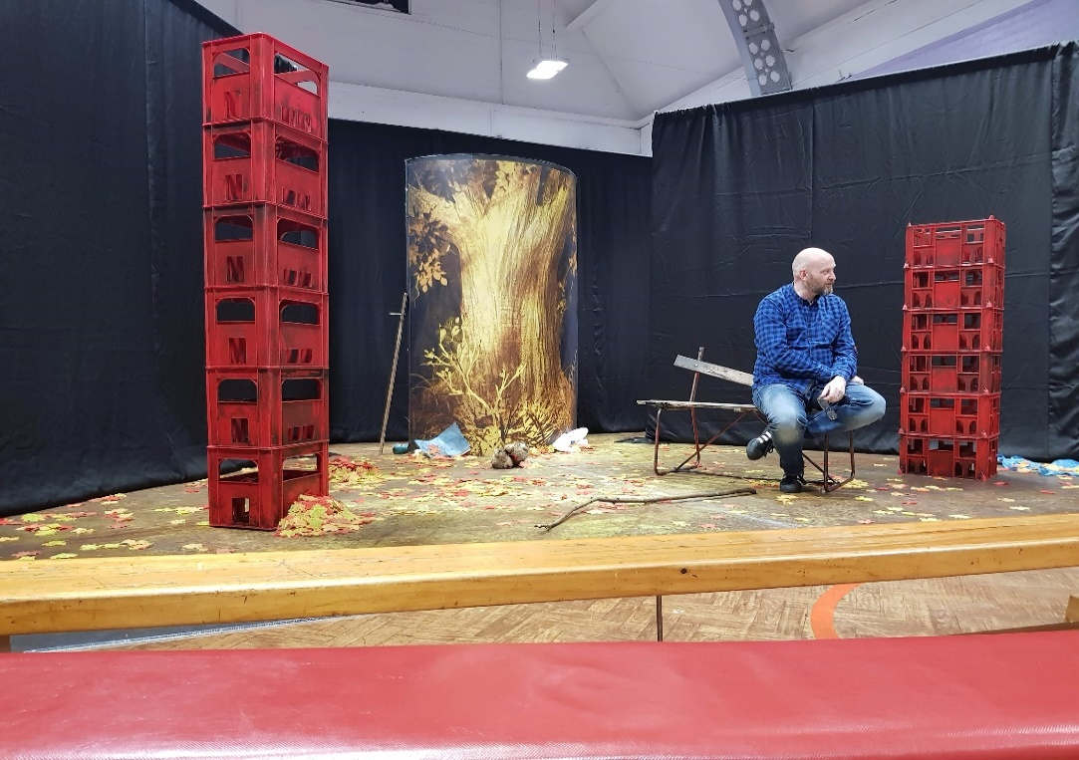
Figure 1- Richard Holmes- Artistic Director of Big Brum
October 2018 | Creating spaces for young people to explore what it means to be human

Human Spaces- An evaluative Case study
Creating spaces for young people to explore what it means to be human
Contents
Executive summary 2
Introduction and Context 2
Literature Review 5
Findings and Analysis 7
Findings and Recommendations: 11
References 14

Chris Bolton is a senior lecturer in drama education. Before this role, he worked in a secondary school as a Drama Advanced Skills Teacher. He has a keen interest in how drama can create spaces for dialogic learning by working with reasoned imagination and the impact of education systems on the nature of drama in education.

This evaluative case study was undertaken in accordance with Birmingham City University’s ethical approval.

Executive summary
Through this evaluative case study of the impact of Big Brum’s work in one school, five central concepts have arisen in how they explore what it means to be human. The concept of co-creating meaning using empathy, imagination, by being present and using fiction to protect young people is evident in their approach and is a valuable contribution to young peoples’ learning. It is also evident through the evaluation that teachers who may not be familiar with Big Brum’s approach need to trust the work being explored and the experience being offered by Big Brum. In addition, teachers need to develop trust in the actor-teachers’ ability to engage young people whilst considering what engagement might ‘look’ like beyond what they expect to see in classrooms.

Introduction and Context
Big Brum, which founded in 1982, delivers Theatre in Education (TiE) programs and special projects to schools and other learning settings, working with children and young people from infants to post-graduates. As part of a Paul Hamlyn Foundation funded evaluation called ‘More and Better’, the company were seeking to capture the impact of their practice on young people across the West Midlands. One of the Big Brum's key success criteria in their approach was, and continues to be, that “Young people have been given a space to explore what it means to be human.” However, Big Brum recognised that it was challenging to turn this success criterion into traditional quantitative evaluation criteria.
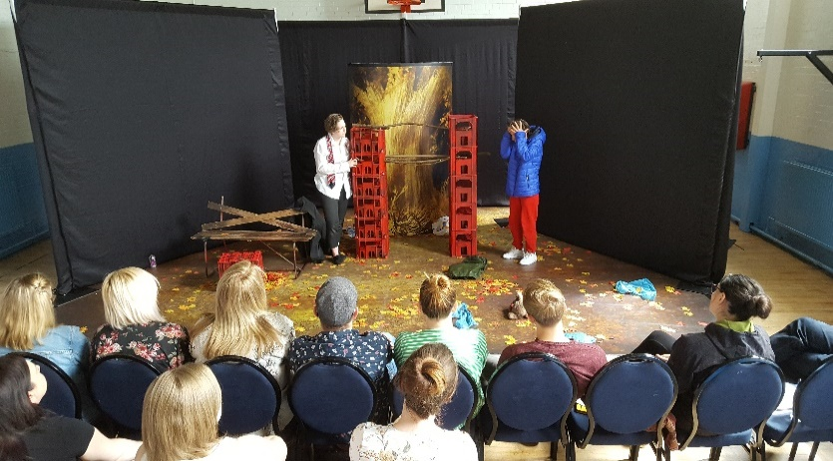
The Human Spaces evaluation project was a small-scale qualitative and evaluative case study to explore the impact of Big Brum’s latest work, ‘Flee’; a theatre in education program based on a new play by local theatre writer, Suriya Aisha on one primary school class in the West Midlands. It was intended that through this evaluative approach we might collaboratively meet the challenge of capturing the human space that Big Brum create through their work and examine the implications of this space on young people. This ‘project-within-a-project’ involved non-participant observations and analysis of Big Brum's actor-teachers working with a group of young people on the play in Benson Primary school, Birmingham. Using the framework from Intellectual Output 1 from the ‘Democracy through Drama’ project provided the observer with an analytical frame to evaluate the practice of the lead practitioner, Richard Holmes. Added to this, the evaluation included a semi-structured interview with the class teacher of that class following the program.
Figure 2- Flee performed by Rosie & Victoria 2018
The Demo:Dram project is currently exploring how democratic classrooms might be created using drama pedagogy. The project defines a democratic classroom as a space for creativity and imagination where the child’s experience is acknowledged, valued, nurtured, encouraged and developed. As part of this, the child is recognised as an individual human being in his or her own right. This definition is not unlike Big Brum’s practice in reality. Thus, the framework to evaluate Big Brum’s approach used the following key concepts, which are believed to be key to facilitating the creation of democratic classrooms:
The subversion of traditional power relations- Facilitators position themselves explicitly as co-collaborators within the meaning-making process
The invitation to participate- Facilitators should invite participants to take part in dramatic activity and participants should be free to choose how much they contribute. The invitation to participate within the drama is continually negotiated and re-negotiated throughout the process
Permission- Participants have permission to contribute within the invitation under the proviso that their contributions are valued so long as they can be justified and/or explained
Value of participant contribution- The value of the participants’ contribution to drama activity should be explicitly elevated so that all contributions are taken seriously.
Questioning- Facilitators should use a variety of questions to develop thinking and the democratic classroom within a workshop. The questions asked should serve a variety of purposes: for clarification of meaning; out of curiosity; in order to motivate thinking; in order to stimulate discussion; and/or in order to challenge preconceptions.
The importance of imagination- Everyone can imagine and this concept should underpin the facilitators’ approach to a dramatic exploration; that is what makes us human. As part of this belief, a democratic classroom can be furthered and upheld by seeking group consensus, which could be termed as living democracy
Repetition and pause- Facilitators could use the idea of repetition and pause within a dramatic exploration. Both concepts can create space in which participants can think, consider and question the drama and its meaning
Embodied teaching- Facilitators should be able to create in themselves “an opening” where they are able to recognise students without judgment. This “openness” also enables facilitators to use their own expressive capacity in order to embody what they teach and therefore bring to life the subjects they are teaching

Literature Review

Much has been written about Theatre in Education (TiE) and its subsequent development from the 1960s (Jackson & Vine 2013, Nicholson 2009). It is clear that Big Brum’s approach continues to develop the original foundations of this movement in its artistic policy by constantly placing the needs of the child at the centre of their practice. As part of this, the company seeks to work in the moment with young people to hear their voices, which develops an in-built respect for young people as human beings in their own right. The trust placed in young people by the company enables the development of a safe space- a human space.
This approach is commendable particularly in the current educational climate, which has seen a reduction in arts provision and an alarming narrowing of the secondary curriculum manifest through the English Baccalaureate (Greevey, et al 2013). In addition there has been and continues to be reduced funding for art activities as a result of cuts to school budgets in real terms (Baisley, 2018) and an ever-increasing value being placed on SAT results at primary schools with the resulting exacerbation in stress and anxiety on young people (Putwain, et al. 2012). Indeed, the House of Commons Education Committee’s (2017: 15) review of primary assessment identified that subjects such as the arts and humanities “have been squeezed out of the timetable in order to ‘achieve coverage’ of the curriculum in preparation for end of Key Stage assessments”. Without a doubt, this context adds to the value and importance of Big Brum’s work. The human spaces that Big Brum seek to create in order for young people to explore who they are and their relationship to the world, is constantly under threat and is being contested by competing forces.
It is also clear that in their pedagogical approach, the company are quickly able to create the space and conditions for young people to know themselves and the world in which they live, something that echoes the thinking of the SCYPT committee’s 1993 manifesto, In Defence of Art and Education. Evidently, within this space, the actor-teachers ruthlessly stick to the notion that real understanding is felt and that telling young people what to think should not be a feature of their work with young people with whom they work (Gillham 1994: 5 in Jackson and Vine 2013: 45). In effect, this subverts the traditional teacher-pupil relationship enabling and empowering young people to use the TiE program to say what they think; what they feel and what something means to them. Big Brum cleverly recognise the need for a humanistic pedagogical approach (Leach & Moon 2008) and the importance of a humanizing curriculum (Neelands, 2001) as both a place to empower young people and to learn from them. This powerful pedagogical approach, therefore, is vital as it “… [allows] children and others to forge their own ways and identities in our complex, knowledge rich society” (Leach and Moon, 2008:65).
The qualitative approach of this evaluation supports the valuable work of the company. Indeed “educators have found that the thick descriptions that qualitative research yields can help to thoroughly recapture the lived experience of leaders and participants when they encounter dramatic activity” (Taylor. 2006:7 in Ackroyd 2006). Therefore, the use of non-participant observation and interviews has captured not only my experiences as the researcher but also the experiences of a teacher, and has enabled an evaluation of those experiences when the work of Big Brum was encountered. By focusing on the relationship between human experience and meaning, this evaluation gives rise to potential new and different understandings about the power of Big Brum’s TiE approach. Adams’ (2013: 287 in Jackson and Vine 2013) call for TiE to be used for “education” rather than “schooling” usefully recognises this potential! His suggestion that TiE goes beyond narratives that “often state that TiE is simply participatory theatre in the service of education or in support of a specific curriculum” (ibid.) is evidently starting to be realised in this evaluative case study.
The philosophical position taken therefore was one that values experiences of the world as personal, individual, subjective and interpretational. It is believed that this way of viewing the research should be celebrated and valued, particularly as it reflects the way in which the company works with young people through theatre and drama. The lens through which the research was viewed valued the possibility of there being different and contrasting experiences and thus the notion that there is an objective experience of the world was rejected. Why would the experience of what it means to be human, be reduced to a number, for example? This position also enabled an exploration as to what extent a teacher felt her pupils gained a greater felt understanding of themselves and the world through Big Brum’s work.
What this means for Big Brum is that the relationship through the evaluation should become dialogic and one that creates transactional room for responses (Freire 1993). The traditional aims of evaluation as a method, such as the accumulation of static findings, have been put aside and exchanged with the aim of generating a communicative process. Potentially, this could also mean that the relationships between Big Brum, schools, teachers and pupils could alter and develop through the evaluation process and thus supports aim 2 of the ‘More and Better’ project; to build and strengthen strategic partnerships and alliances, and raise the profile of the company. The evaluation process will continue to be educational for both Big Brum and other stakeholders.
“I thought that was brilliant because they were all engaged. As a teacher, one of my skills is skimming the room, watching, and they were all engaged throughout. They were so engaged. You could tell that by their responses to the questions.”- Class Teacher

Findings and Analysis
The play, Flee, provides many themes for young people to consider and uses a chance meeting between school-aged children to explore issues of safety in the world. The audience learn that one characters’ experience of life is that of an exploited, homeless refugee whilst the other character is a challenging, disruptive child who is experiencing bullying at both school and home. Within the action of the play, the audience see moments in which both children are cut-off from the world and are fighting to survive. The audience also witness how the relationship between the two boys develops as they both seek to understand the world in which they are living and the decisions that have been made for them.
Before the play began, and in order to contextualise one of the main themes of the play, the class were asked to consider when they had felt lost. The suggestions and experiences were discussed and framed to enable the young people to look for moments of loss in the story.
Two children from two different places impacted by the choices of one world. One worries his Dad will “Kill Im”, the other wonders if his Dad’s been killed. Both bound by decisions too heavy for young shoulders, they find sanctuary in a forest. This is a story about what it feels like to be lost...by choice - but whose choice is it really? What happens when one generation makes decisions without considering the next? FLEE is about who we allow to seek safety.
(Taken from the publicity for Flee)

Observation and Analysis of Practice:
The primary aim of the observation was to explore how the company open a space for young people to explore what it means to be human. To focus this further, a secondary question framed the observation- What is it that the actor-teacher (Rich) does and can this be evaluated using the Demo:Dram intellectual output 1; framework for democratic classrooms?
At the beginning of the work, Rich signified the construction of a democratic space through his use of space and his body. For example, in kneeing down to meet the young people, it was evident that small act changed the dynamic of the space and the relationship with the ‘teacher figure’. In changing his height, Rich’s status and power became equal to that of the young people. It was clear that Rich was not ‘the teacher’ but existing on ‘their level’ both physically and mentally- in a sense they were all in this together! To further strengthen this dynamic, Rich set the parameters of the discussion by claiming that there were ‘no right or wrong answers’. In doing so, the mental space changed. Rather than the transference of knowledge coming from a teacher (or a teacher figure) to the pupils, the parameters of this space demanded that both the young people and Rich would be co-creating meaning.
As the opening discussion progressed, it was clear that Rich was employing dramatic techniques to signify his genuine confusion about the story he was presenting. In doing so, Rich’s voice became slower, measured and he employed the use of pauses. The combination of these elements created an authentic ‘plea’ from Rich for the pupils’ help. To mirror this, the pupils tuned into the seriousness of the problem Rich was discussing and began to empathise with his confusion- they wanted to help him answer his questions. To strengthen this, comments such as, “You feel the movement of the planet better than anyone”, demonstrated Rich’s capacity to build up the young people as experts and re-positioned them as active participants.
Furthermore, the use of the phrase ‘can you imagine?’ by Rich became a significant driver in engaging the learners with the story. The power of this question to both challenge and motivate the learners, acted as a lever to elevate the young people to a different learning space; it altered their perception of learning. Alongside this, the agentic space that this question created was exemplified with one pupil’s response to objects in the set; “I’m not interested in the look of the book but what’s inside the book” (pupil A). This response typified the impact of the company’s approach and said a great deal about the potential of aligning practice with young peoples’ curiosity. Similarly, Rich asked the young people to talk about and discuss what they already knew about the world. Again, this affirmed the value of the learners’ contributions, elevated their worth, and repositioned their knowledge of the world as respected.
Whilst these aspects of practice were noticeable, what was clear was Rich’s strong ability to link together the stories, ideas, responses and experiences of the young people. In doing so, it was evident that the weaving together of these things, using the imagination as a thread, created a communal experience. Whilst this was created using verbal cues, comments and questions it was also supported by non-verbal gestures, glances, nods. These subtle cues in collaboration with the verbal signs all formed, informed and reformed the communal experience of the young people.
Further to this, Rich weaved together the collective imagination through the skill(s) of listening and responding-in-the-moment. The impact of this again demonstrated and signified to the young people that their ideas were important, useful and valuable in searching for what the story meant. Similarly, time appeared to be slowed down, which created a useful space to explore the central ideas- a human space. This perception of slowing time allowed the company to replay action and image to support young peoples’ understanding of the story and moments within it. The re-created moments further engaged the young people and gave them a chance to re-imagine and work out the situation.
Finally, one key moment that the workshop facilitated was captured through a young person’s response about the story- “Sam is lost when he thinks the teachers won’t come” (pupil B). Rich skillfully responded to this unexpected statement by asking the young people if they thought that the teachers would come to help Sam (character from Flee) in the fictional world. The gut response from the young people was “no” and this created a space in which the young people could begin to discuss their relationship to the world of school and their relationship to their teachers in a safe space and through the fiction. This was not only facilitated through the fictional world of the drama but also through the company’s approach and Rich’s skill of combining story with the young people’s thinking.
Interview:
The interview took place with the class teacher involved in the observation of practice earlier.
- I know you have worked with Big Brum before, but what is your initial response to the work shown and explored today, what’s good about it?
I think what’s good about it is that it talks about real issues and issues that impact upon our children. It goes beyond our curriculum, and what we have to cover. We’ve got children who have come from other countries who have been abused and who have seen people being murdered. These children are so distressed because they don’t have a clue what is going on. So I think it’s really good for our children to learn about the things in the play because it makes them more understanding of others and the plight of others. One thing we don’t have a problem with is different cultures in our school and I think this is so beneficial, every primary school should do something like this in today’s culture because of the way things are going. These young people are going to be our new generation, the people who will look after us when we are old. And the way things are changing…
- Absolutely, I wouldn’t disagree with anything you’ve said there. If I were an outsider, just observing for the first time, and I didn’t understand the method that Big Brum employ, how do you know as a teacher that that those young people are engaging in the work or that they have a space to explore what the work means?
I think Big Brum they are very good at building up the learning. They start with discussion that is interactive. One thing that I think was really good is that they refer back to the children’s answers so the children didn’t just sit there and think, “O’ they are just asking us a question because they have to”. Actually, they [Big Brum] are interested in our answers because he [Rich] was actually using their answers in his discussion when he came back and discussed the different things that they’d seen. I thought that was brilliant because they were all engaged. As a teacher, one of my skills is skimming the room, watching, and they were all engaged throughout. They were so engaged. You could tell that by their responses to the questions.
- Without naming pupils, do you think there are any pupils for whom their experience of the work really resonated with them in particular?
Oh yes, absolutely. There was a little boy sitting at the front who has very challenging needs academically but he was answering questions and he seemed alive. The way they dealt with him was great because they made him feel valued and they were interested in what he had to say. We have many children that join us and this is the first time they have been in education in this country. You know they are just learning the language and they have some terrible life experiences. I think many of our children definitely related to the work. Especially the bit about racism. I can share that racism has been in an issue in our diverse community.
- Part of the evaluation is about how Big Brum and their work can open up spaces for democratic learning; everyone feeling valued, opinions not oppressed. Could you see that?
Yes, that was clear. My colleague and I have decided that we are going to follow-up the work with some creative tasks in lessons. We are going to have a debate looking at the issues of refugees to explore why some people don’t want refugees in this country. We are going to use this to create a space to discuss this sensitive issue. We will link this to UNICEF. I think because this is a sensitive issue. By doing things like this- Big Brum’s work in school -the pupils will become better people, because they will have a better understanding of the world outside; they’ll explore how to be. I want the children to share their prejudice in a safe space and Big Brum have enabled me to do this as a teacher. There are some challenging issues in the work but through Big Brum’s approach we will be able to discuss.
- I suppose they do this through a safe and protected way?
Yes, the pupils were really into this, they felt safe to discuss. They were so engrossed. It was so different to normal school because the young people could use the story to talk about things that were important to them. I could tell this as some of those in my class were answering questions and even talking to people that they don’t normally talk to.
- What did you think when Pupil B said “Sam is lost when he thinks the teachers won’t come”? There was a real sense that some of the pupils thought that Sam couldn’t trust his teachers. What does this mean for you as their teacher?
As their teacher, I would not have known this unless Big Brum had created the conditions in which the class could discuss this. It was quite revealing for me. I guess it means that I need to work on my relationships with pupils in the class to develop that sense of trust. I’d never really thought about it before, I’d just assumed that as I was their teacher my pupils would trust me to some extent. I suppose Big Brum have created the space for my class to think about their relationships to the world and their school and maybe even me as their teacher. This goes beyond a normal classroom environment and is probably more important to their education than a math’s lesson.

Findings and Recommendations:
By combining the observation and analysis with themes arising from the interview with the class teacher, the following findings are presented and discussed. It is intended that the following section begins to consider Big Brum’s impact on understanding what it means to be human for young people experiencing the work.
- The co-creation of meaning is central to the pedagogy of Big Brum. Holding to this central tenet is both vital and liberating (Freire, 1993) in the creation of a human space to explore what it means to be human. The relationship between facilitator and learner that arises because of this is powerful and affective. This relationship also re-aligns the expectations of young people within a school context so that they become agentic in the direction of learning but also empowered through the elevation of their contributions. This was also observed by the class teacher in her comment “It was so different to normal school because the young people could use the story to talk about things that were important to them”. This is further supported by the pupils’ discussions around trust and teachers.
- A plea for help- appealing to empathy is a significant driver in the exploration of what it means to be human and undoubtedly owes something to Heathcote's strategy of "man in a mess". By asking for help, an empathic response is required and it is from this that young people are invited to the space to question themselves, their feelings and their values about not only the fiction but also through the fiction itself. In essence, using empathy in this way provides an affective learning experience that transcends the everyday requirements of a school system.
- Imagination- using the imagination as a teaching tool is key to understanding the meaning of being human and our relationship to the world. Using the imagination acts as a lever from which young people, indeed everyone, can have the opportunity to consider alternative realities, potential changes to the world and perceived limitations of the world in which we live. Exploring these ideas, through the imagination, is a unique approach that has enabled Big Brum to have such a significant impact on the lives of young people.
- Being present- responding in the moment is, whilst a relatively simple idea, a foundational aspect of creating a human space. This involves tuning the ear to the needs of the young people working though the fictional world and being able to respond appropriately to their responses in an instant. The act of being present also demands that the facilitators of this type of work be prepared to ‘let go’ of the plan and pursue the interests of others as this is what their ‘human-ness’ is looking to understand.
- Using fiction to reduce vulnerability forms another aspect of creating spaces for young people to explore what it means to be human. Through the fictional world presented and the exploration of the meaning of that world, it protects young people. This protection invites young people to discuss their world, their relationship to it and what it means to them, particularly as they will always bring their world to the fiction.
Recommendations:
- Teachers need to trust the content of the work being explored and the experience being offered by Big Brum’s approach. In order to do this Big Brum could create a Continued Professional Development (CPD) package for teachers interested in their approach. This offer would not only support teachers in their practice but could also strengthen the case for theatre in education more generally as a way to transcend traditional schooling and inform education (Adams, 2013 in Jackson and Vine, 2013).
- Content of the CPD package could focus on teachers’ need to trust the actor-teachers’ ability to engage young people. To do this, the pedagogy underpinning Big Brum’s approach could be deconstructed and explored, by experiencing a ‘program’ as learners, rather than teachers.
- Additionally, the CPD offer could explore teachers’ perceptions what ‘engagement’ might ‘look’ and ‘feel’ like beyond what they expect to see in a traditional classroom context.
- To add further academic value to this CPD offer, the package could be linked to formal accreditation from Birmingham City University. This could be accredited at level seven (Masters Level) and could open up opportunities for teachers to access the already established Masters in Teaching and Learning course.
- Big Brum are clearly able to create spaces for young people to explore what it means to be human. Additionally, Big Brum are clearly able, through their approach, to create human spaces with young people. This outstanding approach should be explicitly celebrated! This could support the forthcoming creation of media about the ‘More and Better’ project more widely. Furthermore, this evaluation supports the second aim of the project; to build and strengthen strategic partnerships and alliances, and raise the profile of the company.

References
Baisley, A., (2018) Effect of school funding on arts education. NSEAD: The All-Party Parliamentary Group for Art, Craft and Design in Education. Available at http://www.nsead.org/appg/papers.aspx Accessed 24.10.2018
Helen Greevy, Anastasia Knox, Fay Nunney & Julia Pye (2013) Revised: The effects of the English Baccalaureate. Department for Education. Available at https://assets.publishing.service.gov.uk/government/uploads/system/uploads/attachment_data/file/183528/DFE-RR249R-Report_Revised.pdf Accessed 13.07.2018
SCYPT Committee (1993) The Standing Conference of Young Peoples’ Theatre. SCYPT Journal November 1992- January 1993
Jackson, A and Vine, C. (2013 3rd edn) Learning through Theatre. London, Routledge.
Nicholson, H. (2009) Theatre and Education. Basingstoke, Palgrave Macmillan.
Wooster, R. (2007) Contemporary Theatre in Education. Bristol, Intellect.
Dave W. Putwain, Liz Connors, Kevin Woods & Laura J. Nicholson (2012) Stress and anxiety surrounding forthcoming Standard Assessment Tests in English schoolchildren, Pastoral Care in Education, 30:4, 289-302
House of Commons Education Committee (2017) Primary Assessment- Eleventh Report of Session 2016–17. Available at https://publications.parliament.uk/pa/cm201617/cmselect/cmeduc/682/682.pdf Accessed 20.10.2018
Leach, J., & Moon, B. (2008) The Power of Pedagogy. London: Sage.
Taylor, P., (2006). Power and Privilege: re-envisioning the qualitative research lens, in Ackroyd, J., (2006). Research methodologies for drama education. Stoke-on-Trent: Trentham Books.

Benson Primary School serves the community of Hockley in Birmingham and is a larger than average primary school. Almost all pupils come from a wide range of minority ethnic groups with the proportion of pupils supported by the pupil premium funding being well above the national average. The proportion of pupils who have SEN and/or disabilities is also above the national average (Ofsted 2018). The research for this case study involved a year 5 class of 28 pupils.
For more information about the Democracy through Drama project (Demo:Dram) please visit www.demodram.com

